

**Once one starts thinking about exchange rates….**

# Opening remarks by

Kristin Forbes, External MPC Member, Bank of England

Conference on “Financial Determinants of Foreign Exchange Rates” organised by the Bank of England, Banca d’Italia, and the European Central Bank

15 December 2016

Most conversations about economic growth rates seem to inevitably include a reference to Bob Lucas’ famous quote: “once one starts to think about them, it is hard to think about anything else”. There can be a similar obsession when one starts to think about exchange rates - especially when trying to forecast inflation and evaluate the appropriate path for monetary policy.

To prove that this obsession with exchange rates is not just my own eccentricity - but actually something fairly widespread (at least amongst MPC members) - I did a word count for the number of times the words “exchange rate”, “foreign exchange” or “sterling” were used in the Minutes of the Monetary Policy Committee since it was created in 1998. Over this period, the exchange rate (and its related terms) have appeared in 7% of the paragraphs in the Minutes on average. Recently the exchange rate has become even more prevalent - reaching a new record of being used in 20% of the paragraphs over the last 6 months to August (Chart 1).

An even stronger testament to the importance of the exchange rate to monetary policy is how often it is discussed relative to other economic variables at the heart of monetary policy. In contrast to the 7% of paragraphs including exchange rate related terms in the Minutes since 1998, only 5% of the paragraphs include some variant of the word “employ”(including variations such as employment and unemployment), 4% include a reference to “interest rates”, 3% to “wage”, 3% to “oil”, and 1% to “slack” (Chart 2). The only single economic term that I found which is cited more often than the exchange rate terms is “inflation” (which

has averaged 18% percent of paragraphs), albeit this overstates the discussion of inflation as it also includes use of the term *Inflation Report*. I don’t want to make too much of these word counts; they are subject to a number of biases and can yield different results based on how the search terms are constructed. They are, however, consistent with my claim that policymakers on the MPC spend a substantial amount of time thinking about exchange rates.

|  |  |
| --- | --- |
| Chart 1: Proportion of paragraphs in MPC minutes including exchange rate terms (6 month average) | Chart 2: Proportion of paragraphs in MPC minutes that include given terms (since 1998) |
|  |  |

It is not surprising that exchange rates receive so much attention from policymakers. They are critical to understanding sharp movements in inflation in open economies such as the United Kingdom. For example, consider the MPC’s last forecast in November, which predicted that CPI inflation would reach 2.8% in 2018 and remain above our 2% target in three years’ time. Sterling’s depreciation since the end of 2015, and especially its sharp depreciation since the June referendum on EU membership, are critical drivers of this inflation overshoot. Figure 3 shows a rough simulation of the effects. It shows the inflation forecast from November, as well as estimates of what the inflation forecast might have looked like if sterling had not depreciated. This scenario does not fully capture the multifaceted ways in which exchange rates affect inflation over the forecast, but relies on mechanically removing the impact as estimated by a DSGE model.1 This mechanical simulation suggests that sterling’s depreciation since the end of 2015 will raise inflation by about ¾ pp by the middle of next year - the same amount by which inflation is expected to overshoot our 2% target. These are only rough simulations, but they provide a clear example of the importance of the exchange rate for inflation and setting monetary policy.

1 More specifically, this simulation assumes that the exchange rate movement results from an exogenous exchange rate risk shock and that pass-through is relatively prolonged, as estimated by the BoE’s forecasting model (COMPASS). It does not attempt to control for the specific shocks driving the exchange rate, as discussed in Forbes, Hortsoe, and Nenova (2015), or allow for a different speed of pass-through. Since the simulation does not include any additional judgements that often go into a forecast and monetary policy decision, they should be treated as indicative and not precise estimates.

Chart 3: November IR CPI inflation forecast and forecast without mechanic contribution from sterling fluctuations

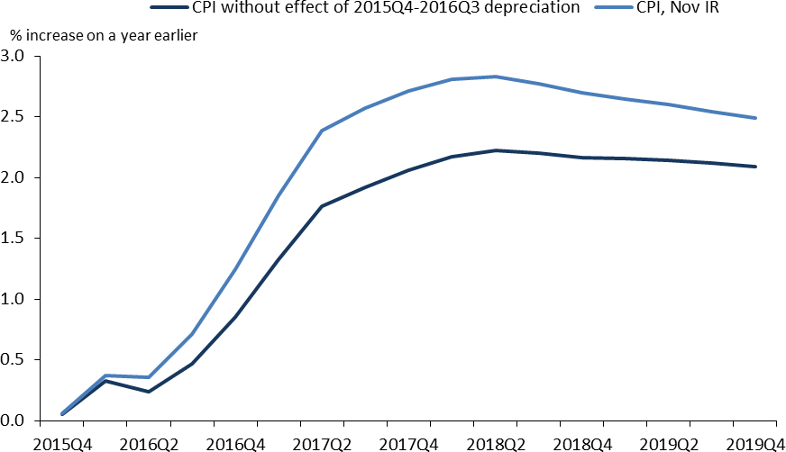Exchange rates are also critical for financial stability. Before the UK referendum this June, a number of our policy discussions focused on the potential risks to various segments of the economy from large movements in sterling. Regulators constantly monitor the risks to major financial institutions related to foreign exchange risk. One of the reasons why emerging markets often benefit less from currency devaluations than developed economies is the way in which currency movements weaken the financial positions of banks, companies and individuals who borrow in foreign currency.

Unfortunately, despite how critically important exchange rates are to so many issues, they are not nearly as well understood as many other economic issues. Academic economists are usually hesitant to even make predictions about whether a country’s real exchange rate will strengthen or weaken. Private sector economists and traders are less reticent - and some have occasionally made large profits predicting where an exchange rate will move - but I have yet to see any convincing evidence that they are able to repeat these profitable bets over an extended period.

Therefore, I am delighted to see this conference drawing together such a knowledgeable group of experts to try to improve our understanding of issues around the financial determinants of exchange rates. I can’t stress enough how important this type of research is to people in policy positions.

The papers today and tomorrow also touch on a number of key issues that are critically important - and which our current understanding leaves something to be desired. Let me touch on two that are key themes in

the sessions today: understanding why interest rate parity sometimes works, but usually doesn’t; and better understanding the causes, concerns, and spillovers linked to high frequency movements in exchange rates.

First, why do intuitive models based on interest rate parity sometimes perform fairly well - but usually perform abysmally? Let me just give a simple example of the challenge in the UK. Panel A of Chart 4 shows the sterling exchange rate index and nominal interest rates news from the end of March through early June of 2014. The two series move together fairly tightly. In fact, this simple version of uncovered interest parity (UIP) explains almost all of sterling’s roughly 1% appreciation over this window. This is a success for this type of model (and, full disclosure, this time period was specifically selected for this reason).

## Chart 4: UIP decomposition

|  |  |  |
| --- | --- | --- |
| **A: Cumulative changes: end March to early June 2014** | **B: Cumulative changes: 23 June to end October 2016** | **C: Cumulative changes: 1 – 30**  **November 2016** |
|  |  |  |

In contrast, look at Panels B and C, which do the same analysis from the period after the UK referendum on EU membership through end October 2016, and for November 2016, respectively. In Panel B, sterling plummets by 15%, but simple UIP calculations suggest changes in interest rates would predict only about a 1.5% depreciation. Or even more disconcerting, during November these simple UIP calculations would have predicted a small depreciation, but instead sterling appreciated by 5.5%.

There were obviously a few other things going on over these periods that may have affected sterling’s value - including the perceived risk of holding sterling and changing expectations of the equilibrium value of the exchange rate in the long-run. Nonetheless, these last two charts illustrate how sharply the exchange rate can move, even when there are only small movements in relative interest rates. The academic literature generally acknowledges that UIP does not tend to hold (due to factors such as risk premia), and a related interest parity condition that has traditionally done somewhat better is covered interest parity (CIP). But this has also broken down recently. Is there any way to better understand when CIP will hold and when it will not? Is there a better way to formalize these other factors?

The papers in the first session today make some progress. They document the substantial deviations from covered interest parity that have existed since the crisis - and the corresponding large systematic arbitrage

opportunities that could therefore exist. Sushko et al. (2016) and Du et al. (2016) both argue that covered interest parity fails not due to transaction costs or bank credit risk. Instead, Sushko et al. argue that they result from demand to hedge US dollars forward. Du et al (2016) argue that they result from frictions in financial intermediation and their interactions with large international imbalances. And Cenedese et al. (2016) show that trading activity in foreign exchange markets is consistent with market making activity being impaired, potentially due to increased balance sheet costs.

The second set of important issues addressed today is better understanding sharp movements in foreign exchange markets - especially flash crashes - and their international spillovers. In October, sterling fell 5% in the space of just 2 minutes in the early hours of 7 October (before bouncing partially back). Or even more striking, on January 15, 2015, the euro-swiss franc exchange rate moved by almost 30% immediately after the Swiss National Bank announced it was no longer supporting its exchange rate floor. Why did these prices

- in what are normally some of the most liquid markets—move so abruptly? Why do these types of sharp market movements sometimes have meaningful spillover effects on other countries (such as after the Swiss franc episode) - but in other cases are fairly well contained (such as after the sterling episode)? Why can such liquid markets quickly become illiquid?

## Chart 5: Sharp movements in exchange rates

|  |  |
| --- | --- |
| Sterling flash crash: $/£ | Swiss de-pegging: €/Swiss franc |
|  |  |

The papers in the 2nd session today make some progress in understanding these important issues. Breedon et al. (2016) focus on the key role played by algorithmic trading during the sharp currency movements around the depegging of the Swiss Franc. They show why these “algo traders” can sometimes provide liquidity, while at other times consume it - a set of issues on which we have remarkably little understanding. The paper presented by Kearns (Ferrari et al., 2016) focuses on the high frequency international spillovers from monetary policy to exchange rates. Both papers are excellent examples of the insights that can be gained by using high frequency data to better understand foreign exchange movements

and spillovers. I remember when moving to daily data was a luxury; moving to a minute frequency is not only a wealth of information, but critical to understanding the factors behind these flash crashes and corresponding spillovers.

To conclude, the organizers of this conference should be congratulated. They are tackling important issues with first order importance for policymakers. The forum shows the range of models and considerations that need to be part of the discussion, as well as the type of careful data analysis that needs to be done to move our understanding forward. If Bob Lucas had attended this conference, maybe his famous quote would

instead have been, “once one starts to think about foreign exchange markets, it is hard to think about anything else”…

**References**

**Breedon, F., Chen, L., Ranaldo, A., Vause, N., (2016).** “Judgement Day: Algorithmic Trading in the Swiss Franc De-pegging”, *Unpublished working paper*.

**Cenedese, G., Della Corte, P., Wang, T., (2016).** “Limits to Arbitrage in the Foreign Exchange Market: Evidence from FX Trade Repository Data”, *Unpublished working paper*.

**Du, W., Tepper, A., Verdelhan, A., (2016).** “Deviations from Covered Interest Rate Parity”, *Unpublished working paper.*

**Ferrari, M., Kearns, J., Schrimpf, A., (2016).** “Monetary Shocks at High Frequency and their Changing FX Transmission around the Globe”, *Unpublished working paper*.

**Forbes, K., Hjortsoe, I. and Nenova, T., (2015).** ”The shocks matter: improving our estimates of exchange rate pass-through”, *Bank of England External MPC Unit Discussion Paper No. 43*, November 2015.

**Sushko, V., Borio, C., McGuire, P., McCauley, R., (**2016). “Failure of covered Interest Parity: FX Hedging Demand and Costly Balance Sheets”, *BIS Working Papers No 590*.